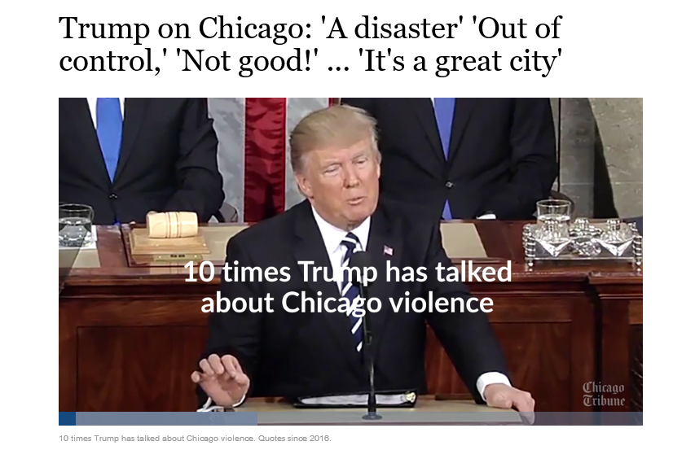

**Deliverables:**

* Submit a single zip-compressed file that has the name: YourLastName_Assignment_5 that has the following files:
  1. Your **PDF document** that has your Source code and output
  2. Your **ipynb script** that has your Source code and output

**Objectives:**

* Use SQL to execute different queries to retrieve data from Chicago Crime dataset and Police statins dataset
* Use Geospatial queries to locate **police stations** and **gun** related crimes (with arrest or no arrest) in every district on **Choropleth** map
* Use Geospatial queries to provide **descriptive stat** for every **district** on Choropleth map
* Use Geospatial queries to locate the **Block** that is the furthest (Maximum Distance) from the police station that has gun related crime resulted in arrest

**Submission Formats:**

Create a folder or directory with all supplementary files with your last name at the beginning of the folder name, compress that folder with zip compression, and post the zip-archived folder under the assignment link in Canvas. The following files should be included in an archive folder/directory that is uploaded as a single zip-compressed file. (Use zip, not StuffIt or any 7z or any other compression method.)

1. Complete IPYNB script that has the source code in Python used to access and analyze the data. The code should be submitted as an IPYNB script that can be be loaded and run in Jupyter Notebook for Python
2. Output from the program, such as console listing/logs, text files, and graphics output for visualizations. If you use the Data Science Computing Cluster or School of Professional Studies database servers or systems, include Linux logs of your sessions as plain text files. Linux logs may be generated by using the script process at the beginning of your session, as demonstrated in tutorial handouts for the DSCC servers.
3. List file names and descriptions of files in the zip-compressed folder/directory.

Formatting Python Code When programming in Python, refer to Kenneth Reitz’ PEP 8: The Style Guide for Python Code: <http://pep8.org/> (Links to an external site.)Links to an external site. There is the Google style guide for Python at <https://google.github.io/styleguide/pyguide.html> (Links to an external site.)Links to an external site. Comment often and in detail.

# Descriptions and Requirement Specifications

## Chicago Crimes

In his first state of the uniion address , president Trump mentioned Chicago violance 10 times [**Trump's State of the Union Address**](http://www.chicagotribune.com/news/local/breaking/ct-trump-tweets-quotes-chicago-htmlstory.html)

## Chicago has more homicides than New York and Los Angeles combined

Columnist Clarence Page wrote an [**article**](http://www.chicagotribune.com/news/opinion/page/ct-perspec-page-trump-murder-rate-jeff-sessions-0103-20180102-story.html) , published by the Chicago Tribune stated that the city of Chicago had **more homicides in the past two years than New York and Los Angeles combined**

# Chicago Police Department

Chicago police department [**CPD**](https://home.chicagopolice.org/community/districts/11th-district-harrison/) issues and publishes on daily basis on its website crime alerts, and press releases for the different [**districts**](https://home.chicagopolice.org/community/districts/) .

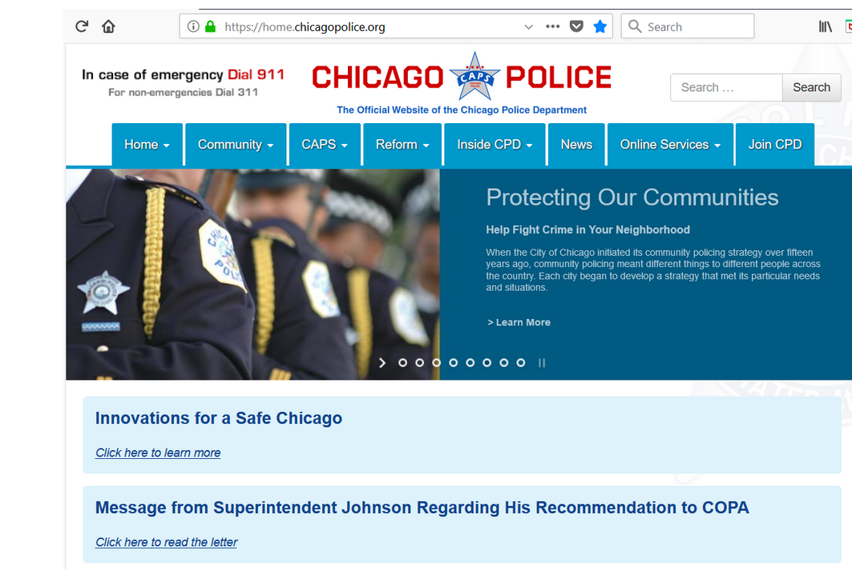

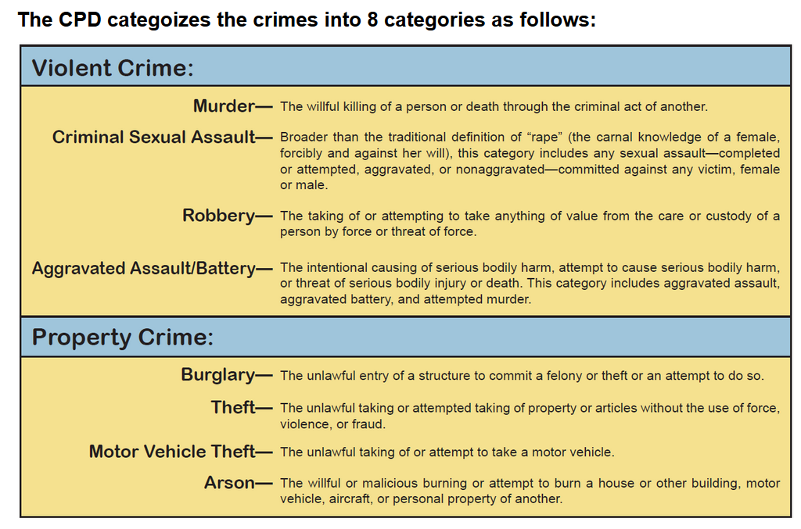

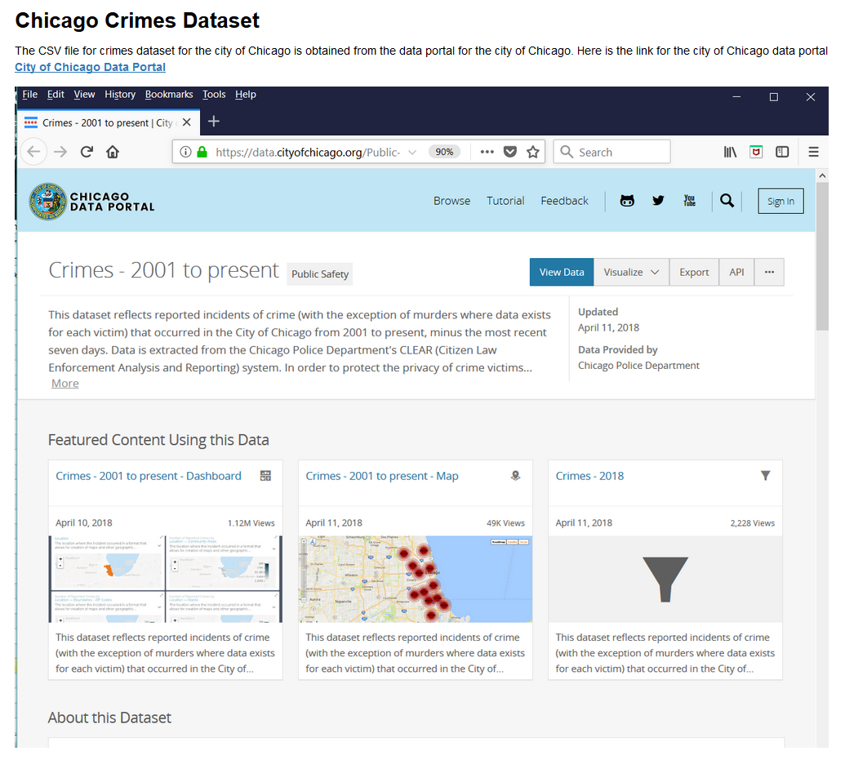

# Loading the Dataset CSV file

Three datasets are need for this assignment:

1. The Chicago police stations in every district
2. The Boundaries.geojson data for district boundries
3. The Crimes dataset

Lets load the CSV file into a DataFrame object and see the nature of the data that we have.

Complete description of the dataset can be found on Chicago city data portal.

Based on Trumps State of the Uniion Address and the article written by columnist Clarence Page and published by the Chicago Tribune, we are interested to retrieve the data for the past two years and perform different types of spatial queries.

There are few of these queries that we are interested in to help CPD and city of Chicago to plot on a Choroplteh map those districts that have highest gun crimes.

Here are examples of those types of quereis:

1. Plot on **Choropleth map** the **districts** and their **Violent Crimes**
2. Plot on Choropleth map the districts and their **Gun** related crimes
3. Which district is the **crime capital** of **Chicago districts**?
4. What the **crime density** per **district**?
5. Plot on Choropleth map those **gun related crimes** that resulted in **arrests**
6. Plot on Choropleth map the gun related crime that is in the **farthest Block** from the **policy stattion** for every **district**

# Chicago Crimes Dataset

The Crimes_2001_to_present.csv is downloaded from Chicago data portal and it has roughly 6.5 million records.

While working in this dataset, It is prudent to make a note of the following:

1. Geospatial queries are very demanding for system resouces like CPU, Memory, and DISK
2. We are interested in the data set of the past 2 years, and when you execute Geospatial type queries, please be advised that these queries slow down your machine.
3. Running this script to work on the data of the past 2 years will require roughly 25 minutes to complete. And requires roughly 40 minutes to complete using the dataset of the past 5 years. And requires hours to complete on the entire dataset with at least 16GB memory.
4. It is a good idea to take a slice (past two years) of the dataset and store it, that will help improve perfoamnce significantly especialy for SEARCH and SORT algorithms that are utilized by the database engine.

## Query #1:

* Calculate the total number of crimes in every district and plot that on Choropleth map

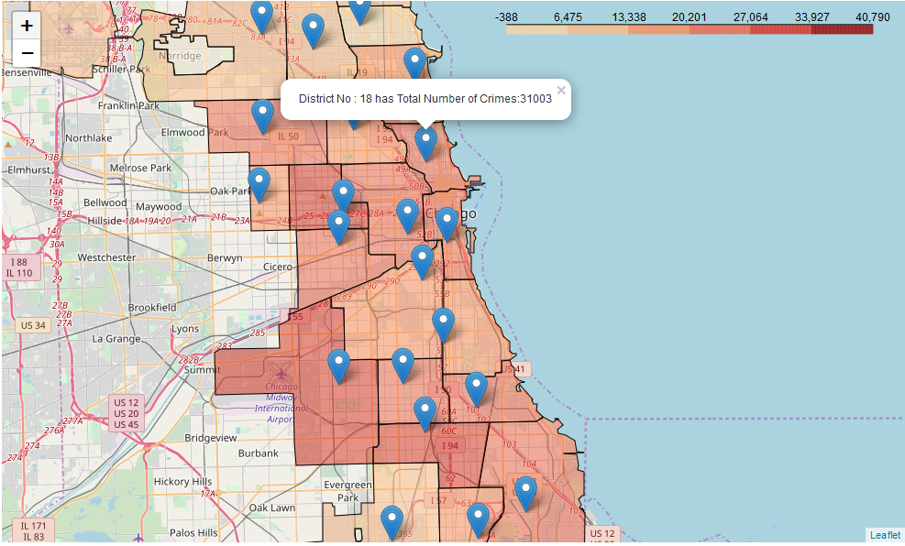

## Query #2:

* Calculate the total number of **violent crimes** in every district and plot that in a table on Choropleth map

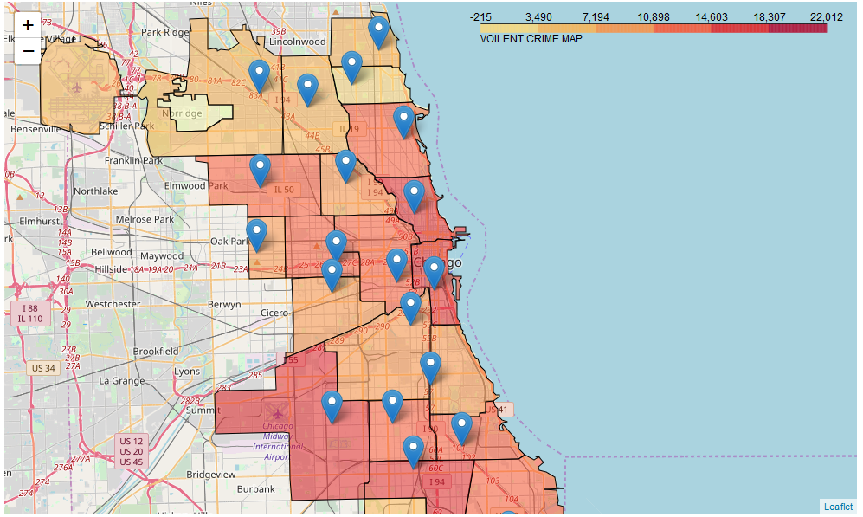

## Query #3:

* Calculate the total number of **gun related violent crimes** in every district and plot that in a table on Choropleth map

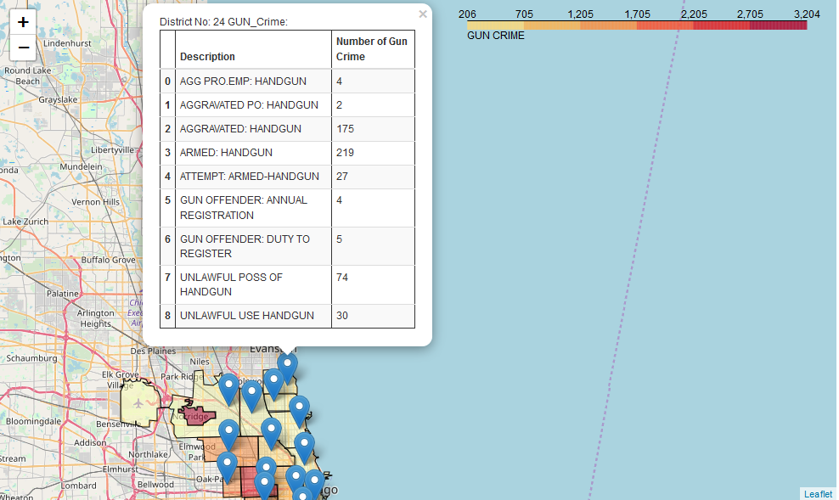

## Query #4:

* Create **Marker Clusters** on Choropleth map for those **gun related violent crimes** that resulted in **arrest (green icon)** and those that **didn't (red icon)**

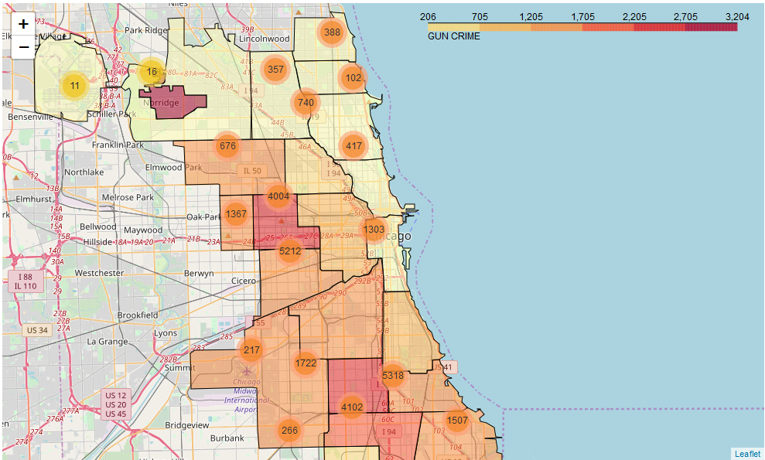

## Query #6:

* Plot on Choropleth map the **farthest Block** that has a gun crime from every police station in every district

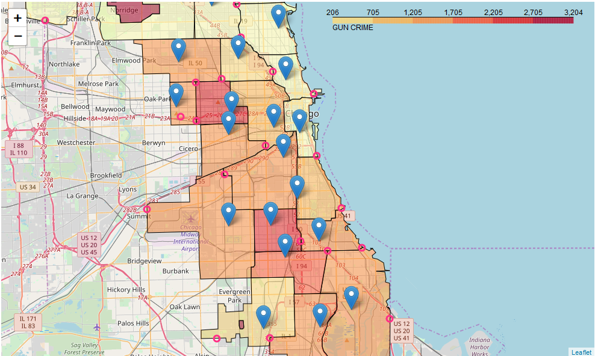

### Query #7:

* Locate the **Block** that has the **highest number of gun crimes**. The popup on Choropleth map shall display the Block in every district along with the total number of gun crimes for that block

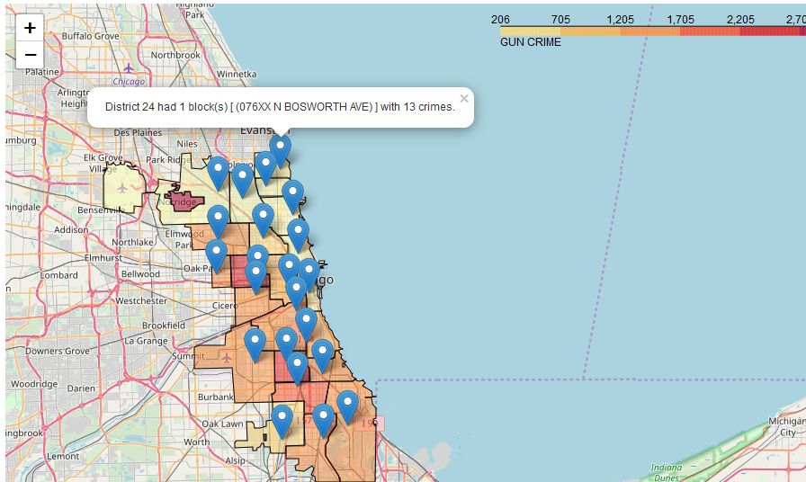

### Query #8:

* Locate the **farthest** UNLAWFUL POSS OF HANDGUN crime from the police station in every district. The popup on Choropleth map shall display the district number and the block

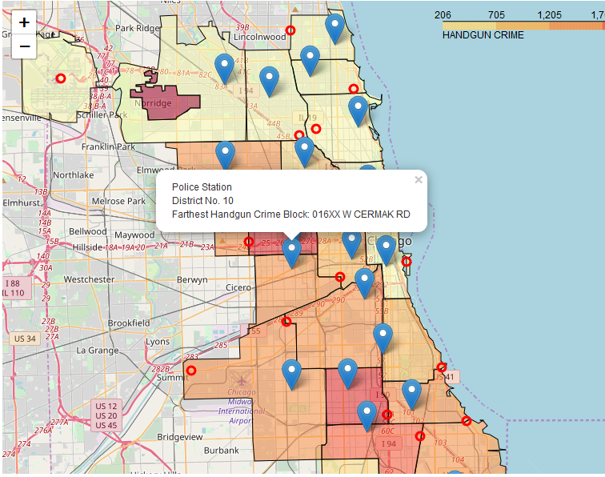

### Requirement #9:

* Create **Marker Clusters** on Choropleth map for those **gun related violent crimes** that have Location Desciption as RESIDENCE in ** (green icon)** and those that have Location Desciption as STREET in **(red icon)**

